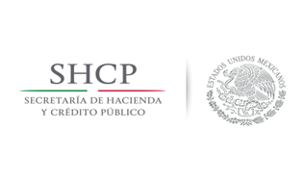 |  | 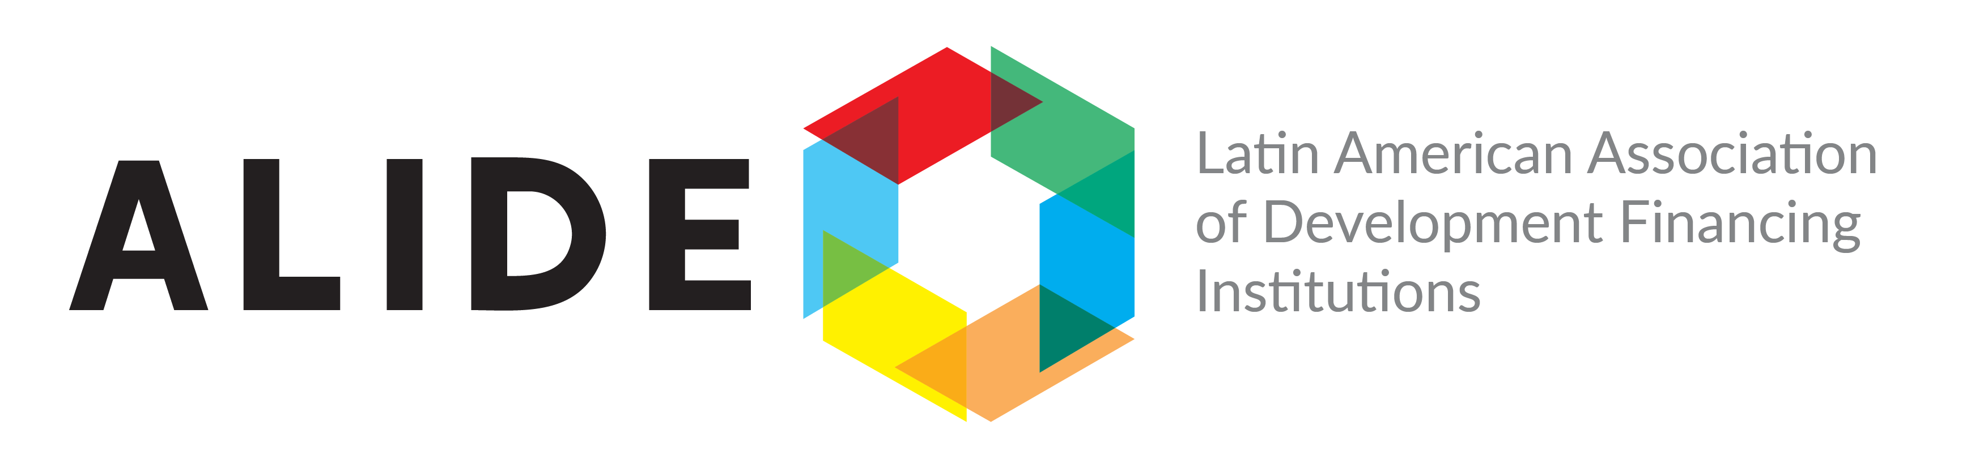
Latin American Meeting on International Business and Investment
Finance and Promotion

Mexico City, Wednesday and Thurdsay, April 11 and 12, 2018

REGISTRATION FORM

1. PERSONAL INFORMATION

NAME:
LAST NAME
POSITION:
INSTITUTION:
INSTITUTIONAL ADDRESS:
CITY/COUNTRY:
TELEPHONE:
E-MAIL:

2. ARRIVAL AND DEPARTURE INFORMATION
You can send this information later. The participants will be provided with transportation between “Benito Juarez International Airport” to the Camino Real Polanco Hotel.

Arrival Date, Airline and Flight number and time:
Departure Date, Airline and Flight number and time:

3. HOTEL
Camino Real Polanco Hotel I will stay at Camino Real Polanco Hotel
Calzada General Mariano Escondo No. 700, Col. Anzures
Del. Alvaro Obregón, C.P. 11590, Mexico City Yes No

Code Group: “SEMINARIO LATINOAMERICANO”
E-mail: reservas.mex@caminoreal.com.mx
Telephone: (52-55) 5263-8888

4. REGISTRATION
Please complete this form and send it by e-mail to: Marlene Zamora, Chief Conferences Unit, mzamora@alide.org
For further information call: (51-1) 203-5520 ext. 216.

